**STREAMLINING TICKET ASSIGNMENT FOR EFFICIENT SUPPORT OPERATIONS**

**Project Description:**

The project aims to automate and streamline the ticket assignment process in support operations using the ServiceNow platform. It focuses on reducing manual efforts, ensuring fair workload distribution, and improving response times by assigning tickets based on agent skills, priority and availability. By leveraging ServiceNow’s workflow automation, assignment rules, and reporting tools, the solution enables faster resolution of customer issues, improved SLA compliance and higher customer satisfaction. The system ensures transparency, real-time tracking, and continuous performance improvement in support operations.

**Project Flow:**

**Milestone 1:** Setting up ServiceNow instance  
**Milestone 2:** Creating a new update set  
**Milestone 3:** Viewing user records in service now  
**Milestone 4:** Viewing and Managing Users  
**Milestone 5:** Creating and managing support groups  
**Milestone 6:** Viewing and Managing Support Groups  
**Milestone 7:** Implementing Access Control for Ticket Operations  
**Milestone 8:** Initiating Workflow Automation through Flow Designer  
**Milestone 9:** Conclusion

**Milestone 1: Setting Up ServiceNow Instance:**

1. Sign up for a developer account on the ServiceNow Developer site “https://developer.servicenow.com”.
2. Once logged in, navigate to the "Personal Developer Instance" section.
3. Click on "Request Instance" to create a new ServiceNow instance.
4. Fill out the required information and submit the request.
5. You'll receive an email with the instance details once it's ready.
6. Log in to your ServiceNow instance using the provided credentials.
7. Now you will navigate to the ServiceNow.

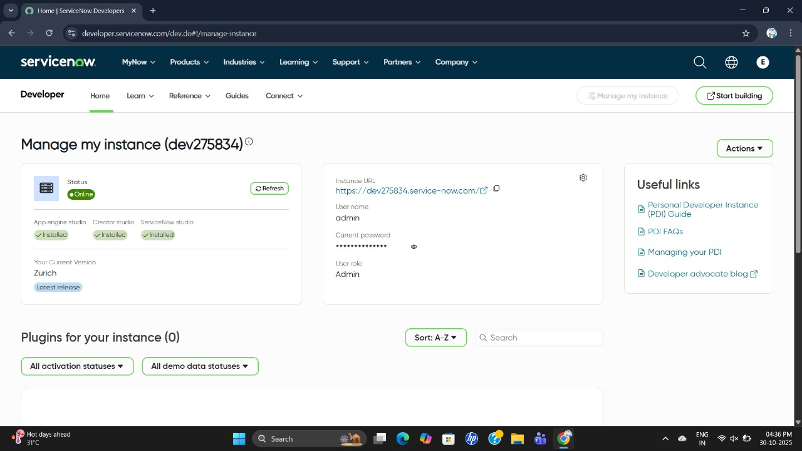

**Milestone 2: Creation of New Update Set:**

Go to User Administration → Users, click New and enter details like:  
1. User ID: manne.niranjan

2. Name: manne Niranjan

3. Email: manneniranjan@gmail.com.  
4. Set Calendar Integration: Outlook

5. Time Zone: America/Los_Angeles, and check Active.  
Finally, click Update to save.

**Method 3: Viewing User Records in ServiceNow:**

1. Navigate to User Administration → Users in the ServiceNow application.

2. The User List View displays all existing users along with details such as:

* + User ID
  + Name
  + Email
  + Active Status
  + Created Date
  + Updated Date

3. Use the Search or Filter fields to quickly find a specific user.

4. Click on a User ID to open and view detailed information for that user.

5. This list helps administrators easily manage user accounts and ensure that all active agents are available for automated ticket assignment within support operations.

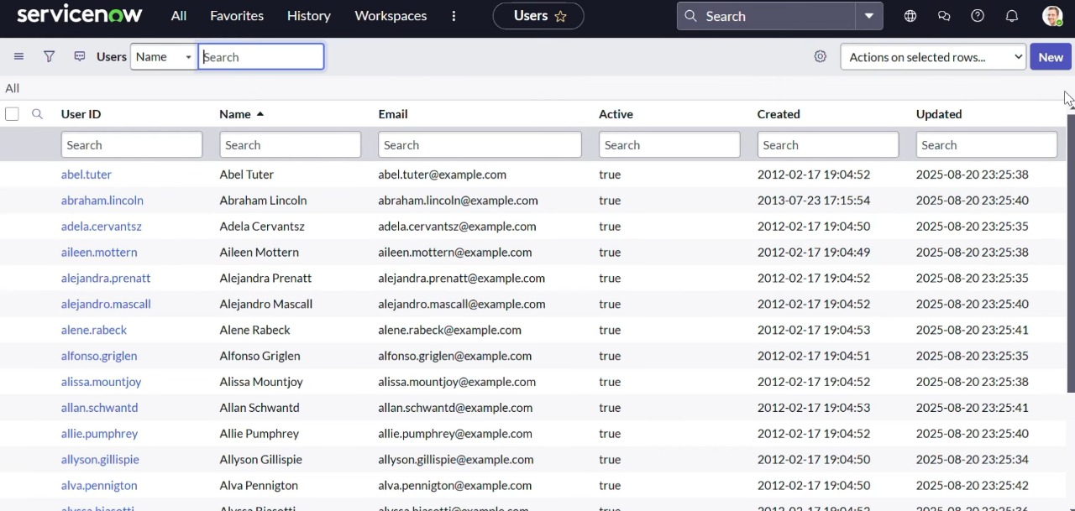

### ****Creation of User Fields in ServiceNow for Ticket Assignment:****

1. Near Columns, double-click to insert a new row.  
Column label: User ID, Type: String

2. Double-click to insert a new row again.  
Column label: First Name, Type: String

3. Double-click to insert a new row again.  
Column label: Last Name, Type: String

4. Double-click to insert a new row again.  
Column label: Email, Type: String

5. Double-click to insert a new row again.  
Column label: Calendar Integration, Type: Choice (Outlook)

6. Double-click to insert a new row again.  
Column label: Time Zone, Type: String

7. Double-click to insert a new row again.  
Column label: Active, Type: Boolean

8. Go to the Header, right-click and click on Save.

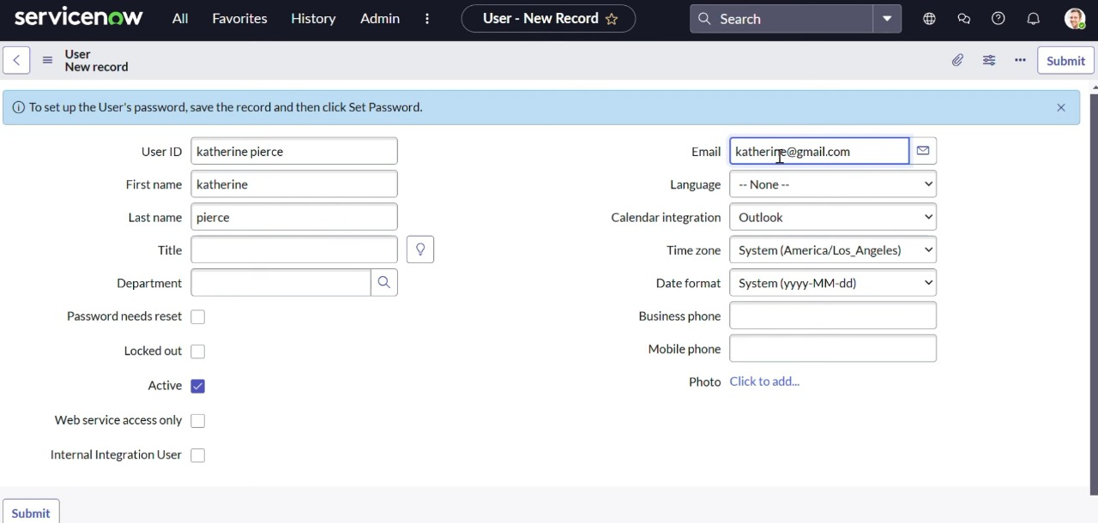

**Milestone 4: Viewing and Managing Users:**

In this milestone, existing users in ServiceNow are viewed and managed to ensure proper configuration for ticket assignment within support operations. The user list helps administrators verify active agents and maintain accurate user data for smooth workflow automation.

**Steps:**

1. In the Application Navigator, type “Users” in the search bar.

2. Navigate to User Administration → Users.

3. The user list view displays key details such as:

* + User ID
  + Name
  + Email
  + Active Status
  + Created and Updated Dates

4. Use the Search or Filter options to find or verify user records.

5. Ensure that all users required for ticket assignment are marked as Active.

**Milestone 5: Creating and Managing Support Groups:**

In this milestone, a new Support Group is created in ServiceNow to organize team members responsible for handling specific ticket categories. Grouping users ensures that incidents and requests are routed efficiently to the right team, improving response time and accountability.

**Steps:**

1. Navigate to User Administration → Groups.

2. Click New to create a new record.

3. Enter the group details:

* + Name: Certificates
  + Manager: Katherine Pierce
  + Description: Handles certificate-related tickets and support tasks.

4. Optionally, add a Group Email or Parent Group if needed.

5. Click Submit to save the group.

**Milestone 6: Viewing and Managing Support Groups:**

In this milestone, the created support groups are viewed and managed within ServiceNow to ensure proper team organization and accessibility. Each group represents a specific functional area responsible for handling particular ticket types, enabling efficient workload distribution.

**Steps:**

1. Navigate to User Administration → Groups.

2. View the existing list of groups such as App Engine Admins, Application Development, etc.

3. Verify that each group has an assigned Manager and is marked as Active.

4. Click New to create additional groups if needed for different support categories.

5. Ensure group details like Name, Description and Manager are clearly defined.

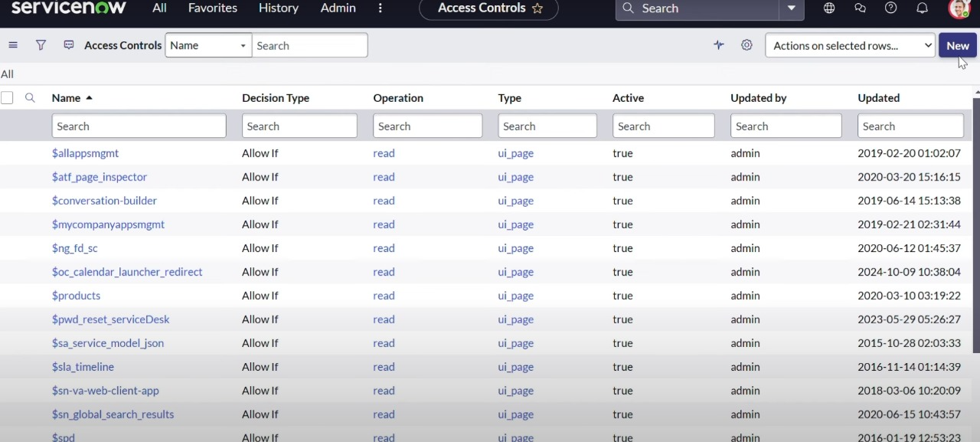

**Milestone 7: Implementing Access Control for Ticket Operations:**

1. Navigate to System Security → Access Control (ACL) in ServiceNow.

2. Click New to create a new Access Control rule.

3. Set the following details:

* + Type: Record
  + Operation: Write
  + Decision Type: Allow If

4. Enable the Admin Overrides checkbox to allow admin users to bypass restrictions if needed.

5. Choose the table operations related [u_operations_related] under the Name field.

6. Select the field service request number (or *issue* as needed).

7. Click Submit to save the Access Control configuration.

8. A Verify Security Rules window will appear. Review and confirm the following:

* + Row-level Access: u_operations_related
  + Field-level Access: u_operations_related.u_issue

9. Click Continue to apply the security rule.

10. Once saved, verify that only authorized users can edit or update records within the specified table.

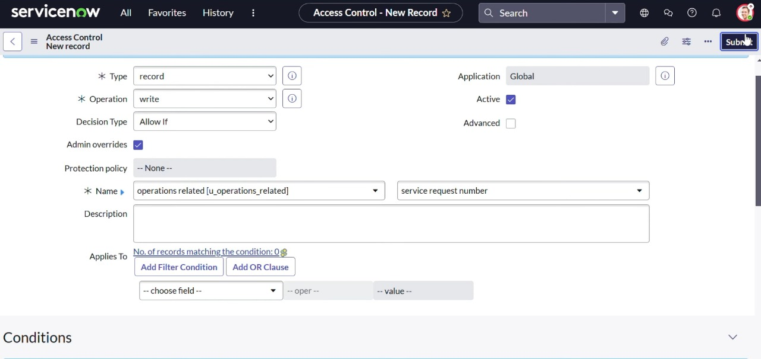

**Milestone 8: Initiating Workflow Automation through Flow Designer:**

1. Navigate to the Application Navigator in ServiceNow.

2. In the search bar, type “Flow” to access the Flow Designer under Process Automation.

3. The Flow Designer allows automation of ticket assignment tasks and business processes.

4. It simplifies complex workflows by defining triggers, actions, and conditions for each step.

5. Use Flow Designer to automatically assign tickets based on conditions such as category, priority, or agent availability.

6. Review Access Controls to ensure the necessary permissions are active before running the flow.

7. Click New Flow to begin creating an automated ticket assignment process.

8. Once configured, test the flow to verify that tickets are assigned correctly and efficiently.

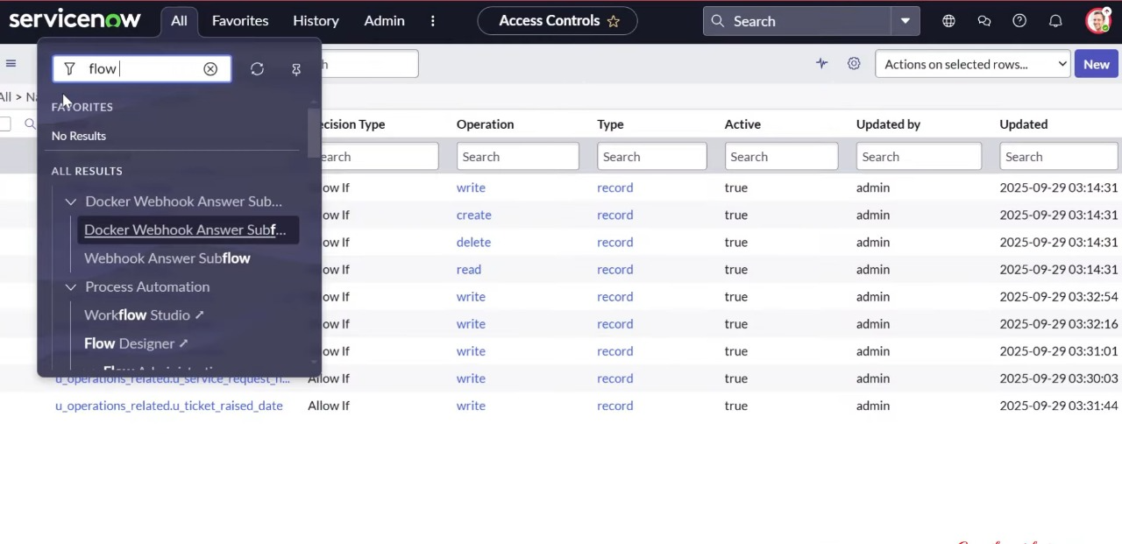

**Milestone 9: Conclusion:**

The project “Streamlining Ticket Assignment for Efficient Support Operations” focuses on enhancing efficiency and accuracy in ServiceNow by automating the ticket assignment process. Through the use of user management, access control and workflow automation, tickets are intelligently routed to the most suitable support agents based on skills, workload, and availability. This reduces manual effort, minimizes delays and ensures secure and seamless operations. As a result, the support process becomes faster, more reliable and effective—leading to improved productivity, quicker issue resolution, and higher customer satisfaction.